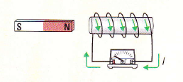**Predictions**

Use Lenz's Law to predict the direction of the induced current   
under the following conditions. Confirm your predictions using

the lab equipment.

**1. Moving Magnet**

|  |  |  |
| --- | --- | --- |
|  | Predicted Direction  of Current | Observed Direction  of Current |
| North end of magnet moving towards solenoid |  |  |
| Magnet remains stationary inside solenoid |  |  |
| North end of magnet moving away from solenoid |  |  |

**2. Moving Solenoid**

|  |  |  |
| --- | --- | --- |
|  | Predicted Direction  of Current | Observed Direction  of Current |
| Solenoid moving towards north end of magnet |  |  |
| Magnet remains stationary inside solenoid |  |  |
| Solenoid moving away from north end of magnet |  |  |

**3. Reversed Magnet**

|  |  |  |
| --- | --- | --- |
|  | Predicted Direction  of Current | Observed Direction  of Current |
| South end of magnet moving towards solenoid |  |  |
| Magnet remains stationary inside solenoid |  |  |
| South end of magnet moving away from solenoid |  |  |

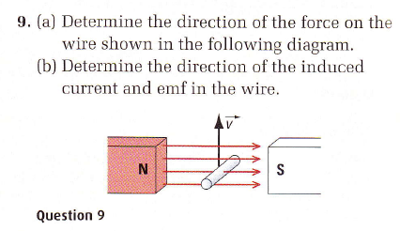

**Practice**

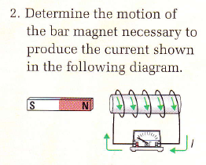

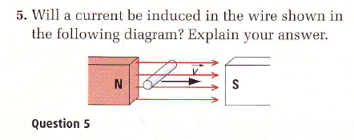

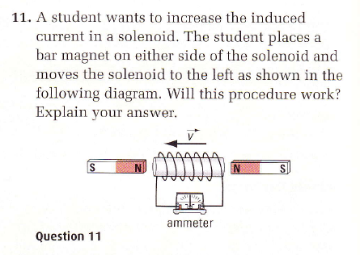

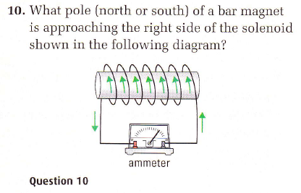

**Answers**

2. away, 11. yes, 9a. down, 9b. into page,

5. no current, 10, south from the right